**Group Members:**

**[Company name] | [Company address]**

PATRONA PUPPY

SuperVised BY: Muhammad Basit Mukhtar

**Table of Contents**

Certificate of Completion 6

Acknowledgement 7

Project Synopsis 8

Functional Requirement 9

Problems Statement: 11

Proposed System 12

Hardware and Software Requirements 13

Website Features 14

Flow diagram 15

User Guide 16

• Homepage (landing Page) 16

• ABOUT US 17

• EXPERT TIPS 18

OUR STORES 19

• MAIN NAVIGATIONS: 20

➢ COOKWARE: 20

➢ REFRIGERATION: 21

➢ APPLIANCES: 21

➢ FOOD STORAGE: 22

COMPARE PRODUCTS: 23

SUB-DIVISIONS OF COOKWARE: 24

o COOKING POTS: 24

o COOKING PANS: 24

o COOKWARE SETS: 25

o HANDI’S 25

o KADAI’S(KARAHI) 26

o GRILL PANS 26

o TAWAS 27

o EGG POACHERS 27

o STEAMERS 28

SUB-DIVISIONS OF REFRIGERATION: 29

o FREEZERS 29

o REFRIGERATOR 29

SUB-DIVISIONS OF APPLIANCES: 30

o BLENDER 30

o BREAD MAKER 30

o COFFEE MAKER 31

o ICE CREAM AND SORBET MAKER 31

o ELECTRIC KETTLE 32

o FOOD CHOPPER 32

o TOASTERS 33

SUB-DIVISIONS OF FOOD STORAGE: 34

o FLASK 34

o SPICE JARS 34

o STORAGE BAGS 35

o LUNCH BOXES 35

o VACCUM BOTTLES 36

Developer’s Guide 37

COOKWARE 37

APPLIANCES 38

FOOD STORAGE 38

COMPARE PRODUCT 39

Task Sheet 41

# *Certificate of Completion*

This is to certify that **Muhammad Usman, Muhammad Hammad,** and

**Syed Qambar** have successfully completed their ACCP Semester E-Project.

Submitted to: **Aptech Computer Education**

On

**January 20th, 2020**

# *Acknowledgement*

First of all we would like to thank Almighty Allah for giving us strength and ability to complete this project.

And then, we would like to express my special thanks of gratitude to our teacher **Sir Tameez Nawab** who guided us on the project *Kitchen Appliances*, which also helped us in doing a lot of new learning and we came to know about so many new things we are really thankful to him.

We are highly thankful to **Sir Tameez Nawab** for his guidance and constant supervision as well as for providing necessary information regarding the project & also for his support in completing the project.

Lastly, we would also like to thank our parents and friends who helped us a lot in finalizing this project within the limited time frame. We also express our sincere gratitude to E-Project team from Aptech Head Office, for their valuable guidance and support for the completion of this project. We earnestly hope that this project will provide all the necessary information required by the user to fulfill his/her inspiration. However, suggestion and Feedbacks for improvements will be thankfully welcomed & acknowledged*.*

# *Project Synopsis*

The PATRONA puppy website is a website which is actually encyclopedia about all types of dogs. The Famous Veteran Patrona is fond of animals specially Dogs, Cats, Rabbits. With her achievements in the field of serving as veteran, she also had interest in writing books on animals and their behavior. All those years she had came across various type of breeds and their characteristics and behavior. Due to passion of photography she has huge collection of animals pictures of all types discovered. Ms Patrona wish to share this images with all for which she had decided to develop an website of various animals.

A Website on Dog was proposed to be developed which will show all the type of dogs found in which location, their behavior, characteristics and so on

The website developed must have the arrangement of the animal’s country wise, type wise, breed wise.

.

# *Functional Requirement*

**Requirement Specification:**

The Web site is to be created based on the following requirements.

1. The name of the website and its motto must be mentioned in the home page.
2. The entire navigational link must be mentioned in the home page, using of Crum navigational link wherever necessary.
3. Different types of puppies and dogs must be mentioned in the website.
4. Sorted by different types of categories like country, type.
5. For each animal, certain behavior must be added.
6. Images collection must be added in the gallery section.
7. Extra links like food, nutrition tips for the dogs and so on.
8. Query link must be added to ask the questions.

# *Problems Statement:*

The PATRONA puppy website is a website which is actually encyclopedia about all types of dogs. The Famous Veteran Patrona is fond of animals specially Dogs, Cats, Rabbits. With her achievements in the field of serving as veteran, she also had interest in writing books on animals and their behavior. All those years she had came across various type of breeds and their characteristics and behavior. Due to passion of photography she has huge collection of animals pictures of all types discovered. Ms Patrona wish to share this images with all for which she had decided to develop an website of various animals.

A Website on Dog was proposed to be developed which will show all the type of dogs found in which location, their behavior, characteristics and so on

The website developed must have the arrangement of the animal’s country wise, type wise, breed wise.

# *Proposed System*

To overcome problems, it is proposed to develop a website which includes their main navigation pages of all the products which they want to sell.

So in this way they can easily enhance their business and expand their sale and services all over the world.

# *Hardware and Software Requirements*

**Hardware**

* A minimum computer system that will help you access all the tools in the courses is a Pentium 166 or better
* 64 Megabytes of RAM or better

**Software**

* Notepad/HTML editor
* Dreamweaver
* IE 5.0/ Netscape 6.0

# *Website Features*

**Problem Statement**

The PATRONA puppy website is a website which is actually encyclopedia about all types of dogs. The Famous Veteran Patrona is fond of animals specially Dogs, Cats, Rabbits. With her achievements in the field of serving as veteran, she also had interest in writing books on animals and their behavior. All those years she had came across various type of breeds and their characteristics and behavior. Due to passion of photography she has huge collection of animals pictures of all types discovered. Ms Patrona wish to share this images with all for which she had decided to develop an website of various animals.

A Website on Dog was proposed to be developed which will show all the type of dogs found in which location, their behavior, characteristics and so on

The website developed must have the arrangement of the animal’s country wise, type wise, breed wise.

# *Flow diagram*

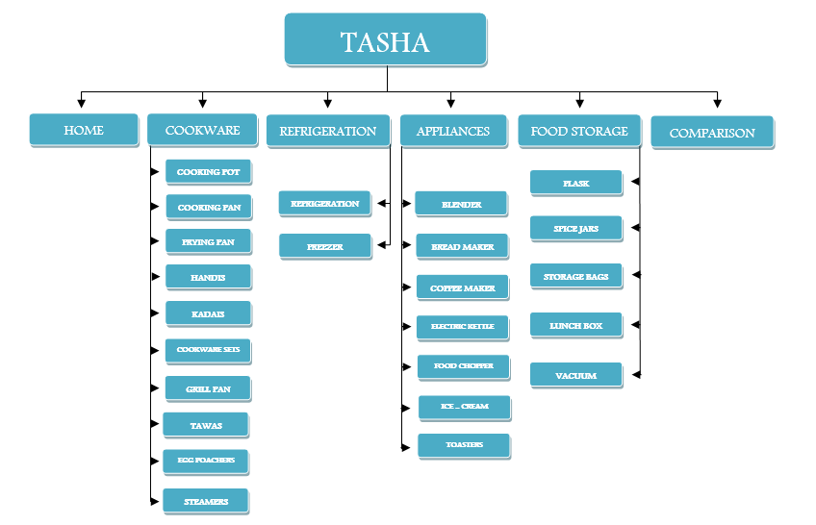

# *User Guide*

* 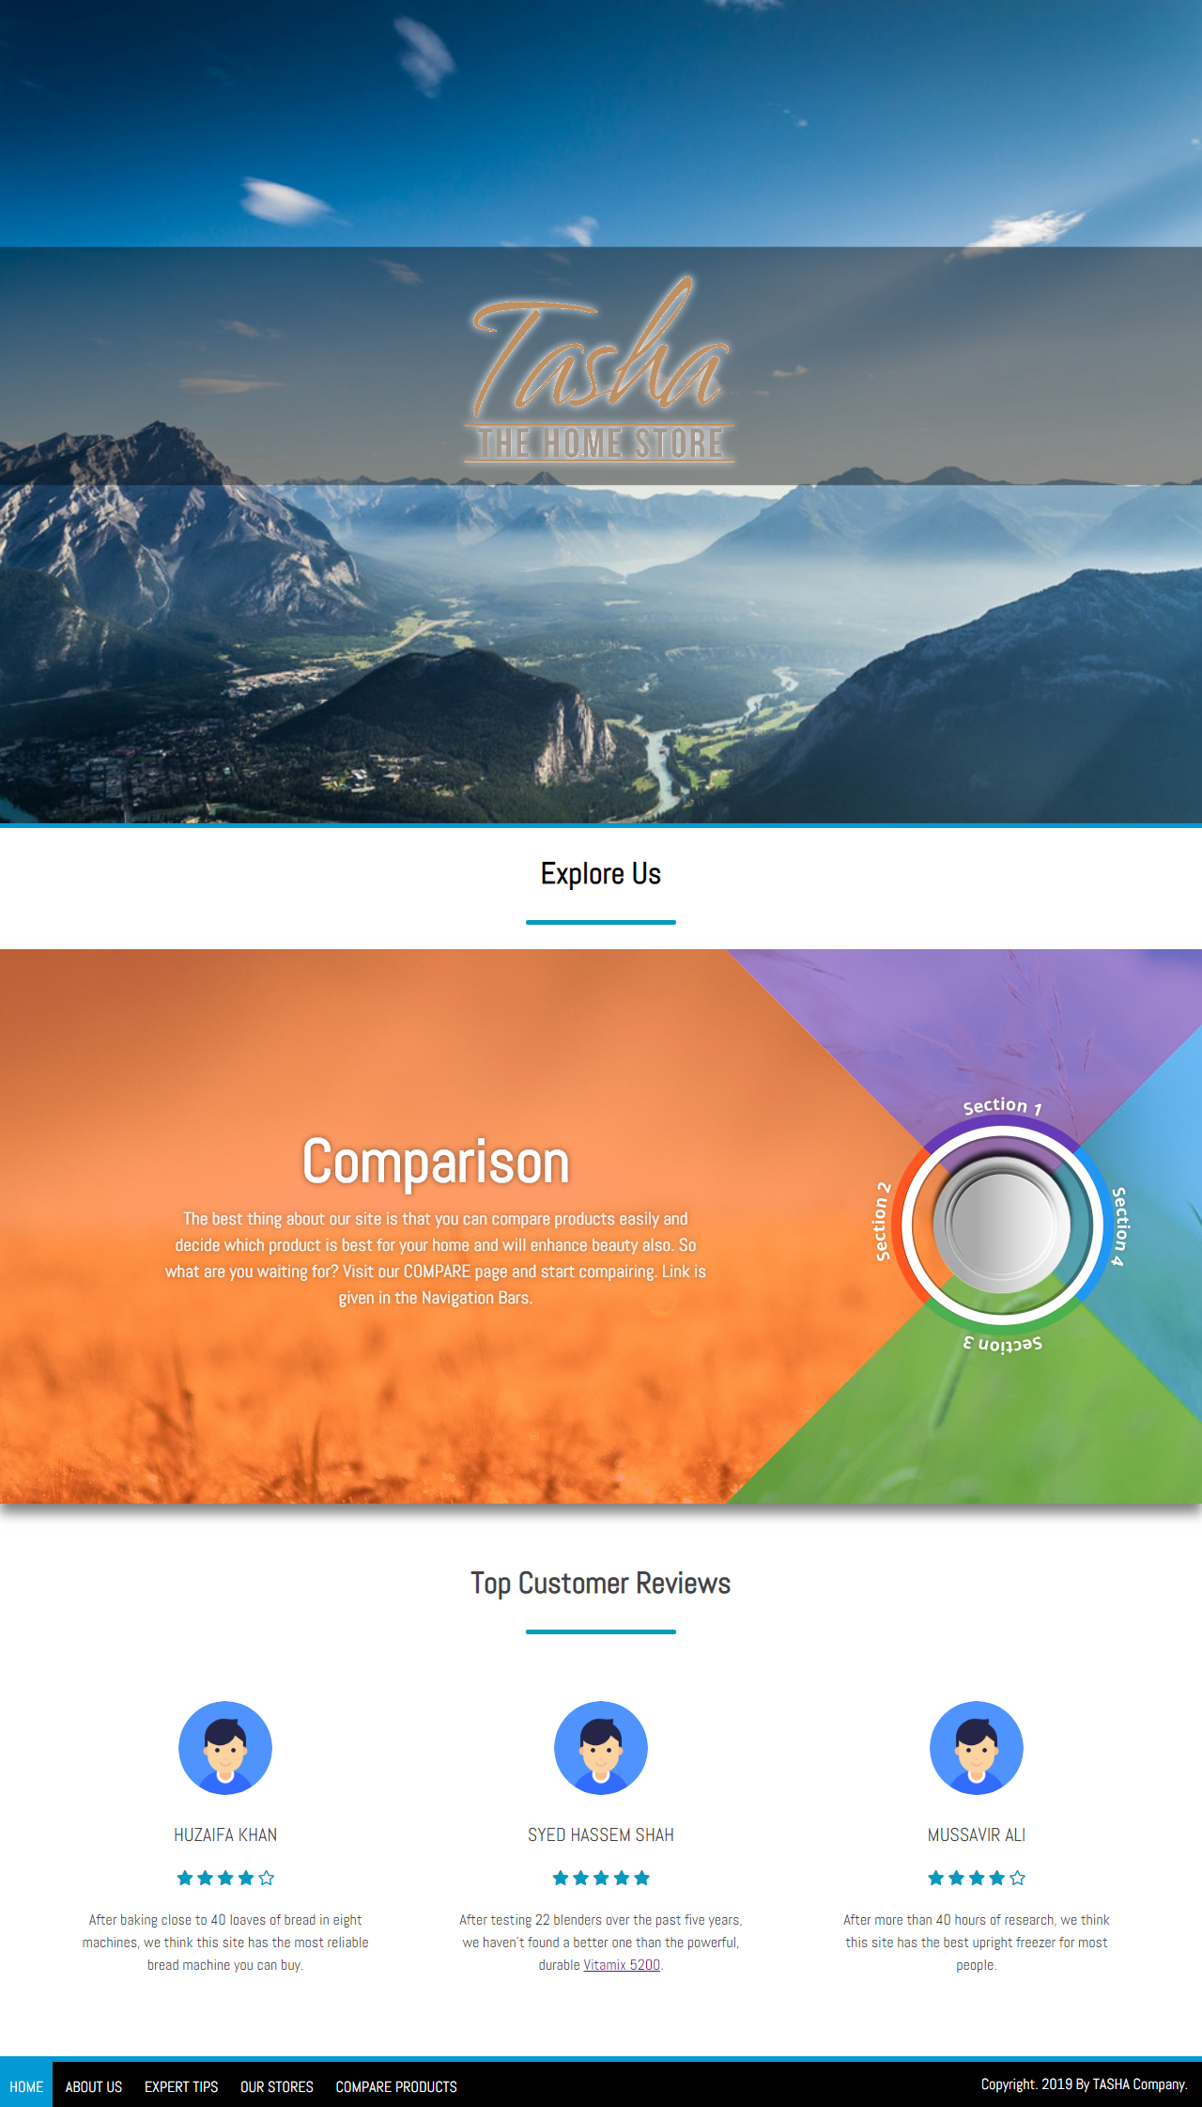*Homepage (landing Page)*
* *ABOUT US*

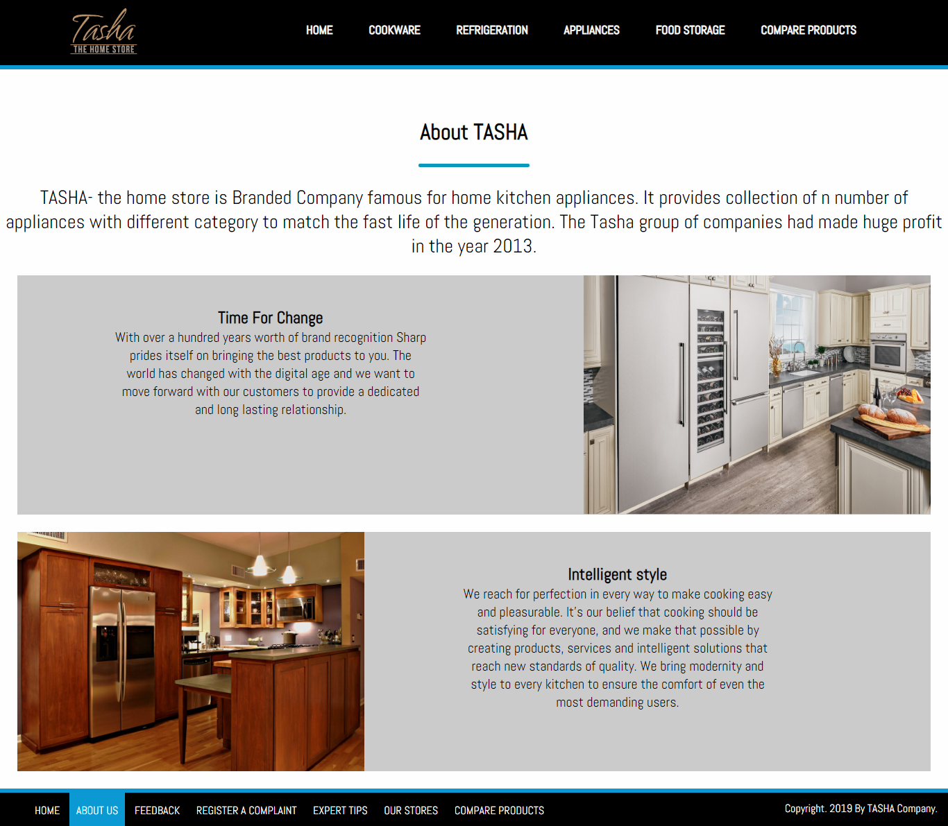

* *EXPERT TIPS*

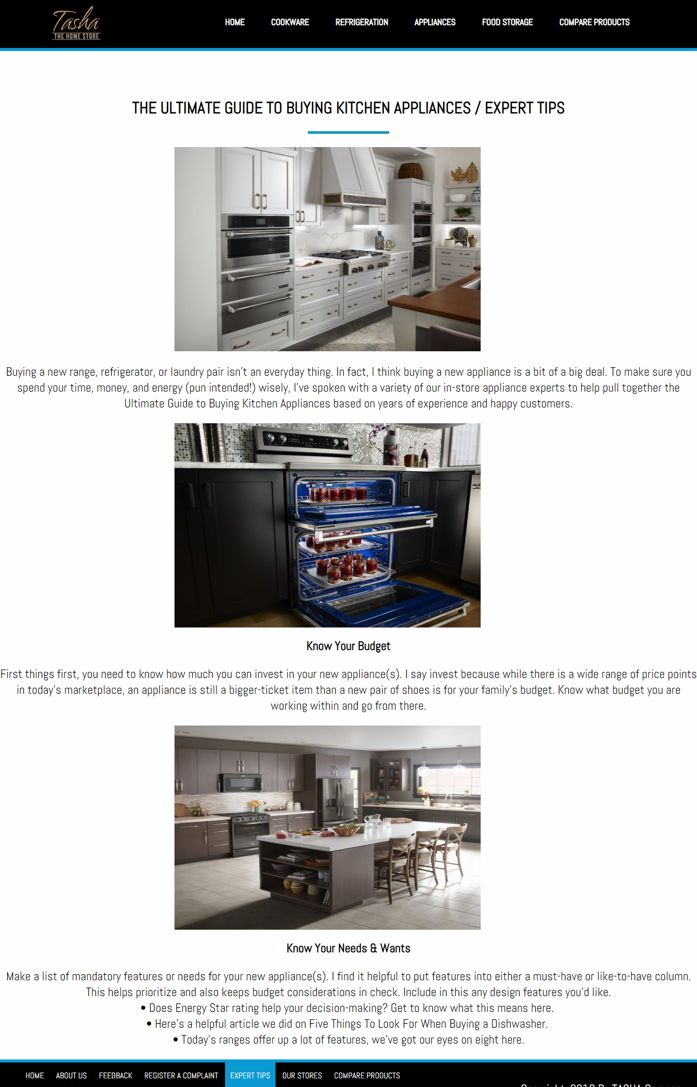

*OUR STORES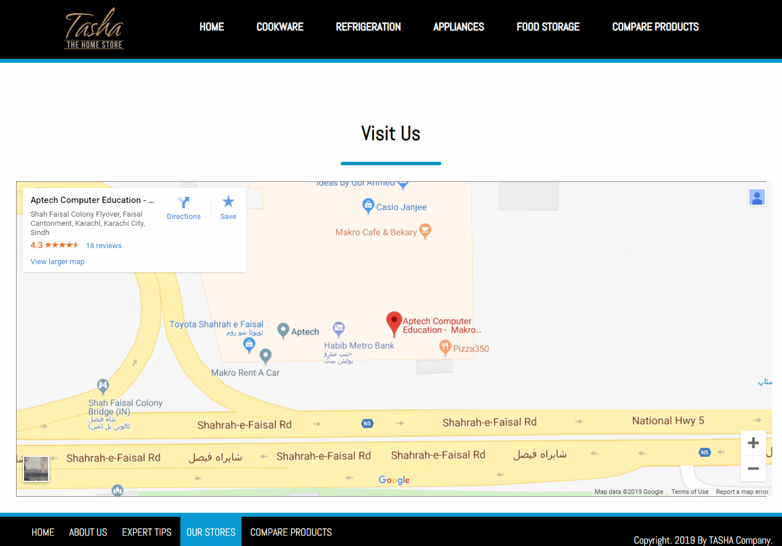*

* *MAIN NAVIGATIONS:­­­­­*
* *COOKWARE:*

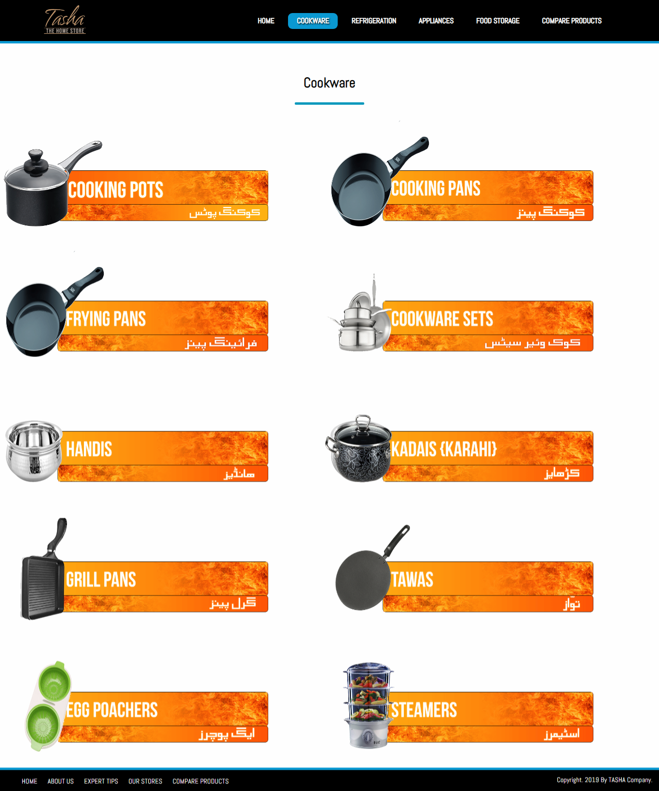

* *REFRIGERATION:*

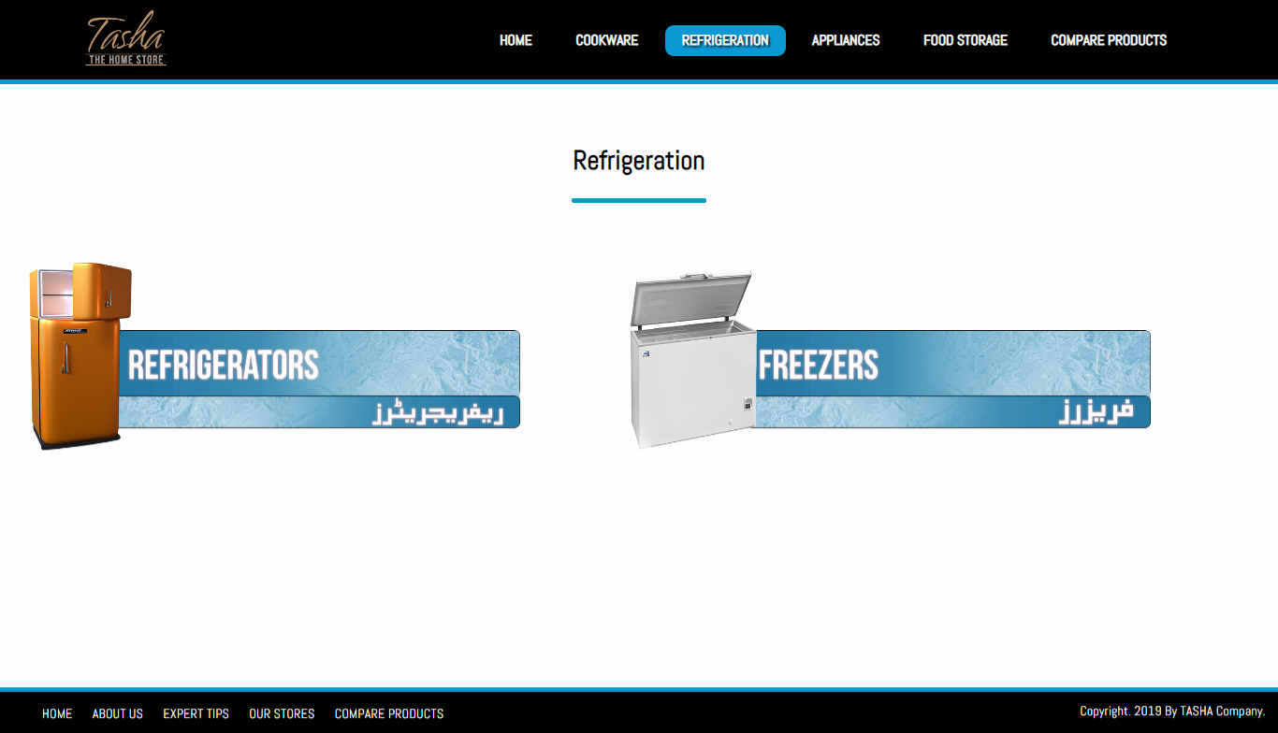

* *t:*

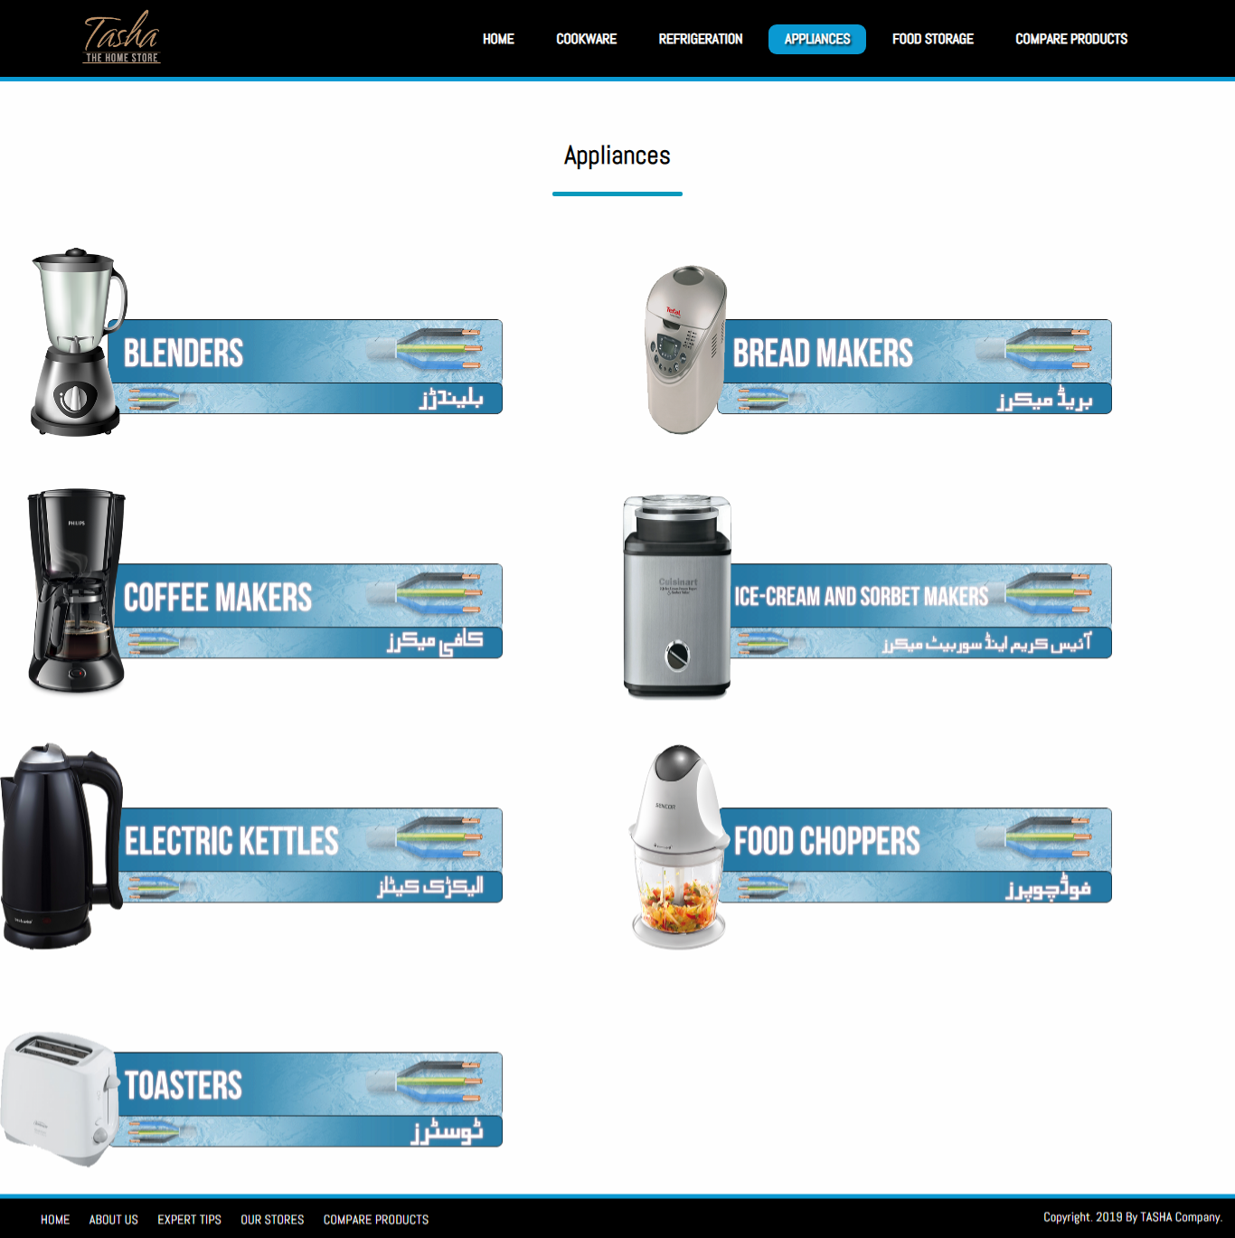

* *FOOD STORAGE:*

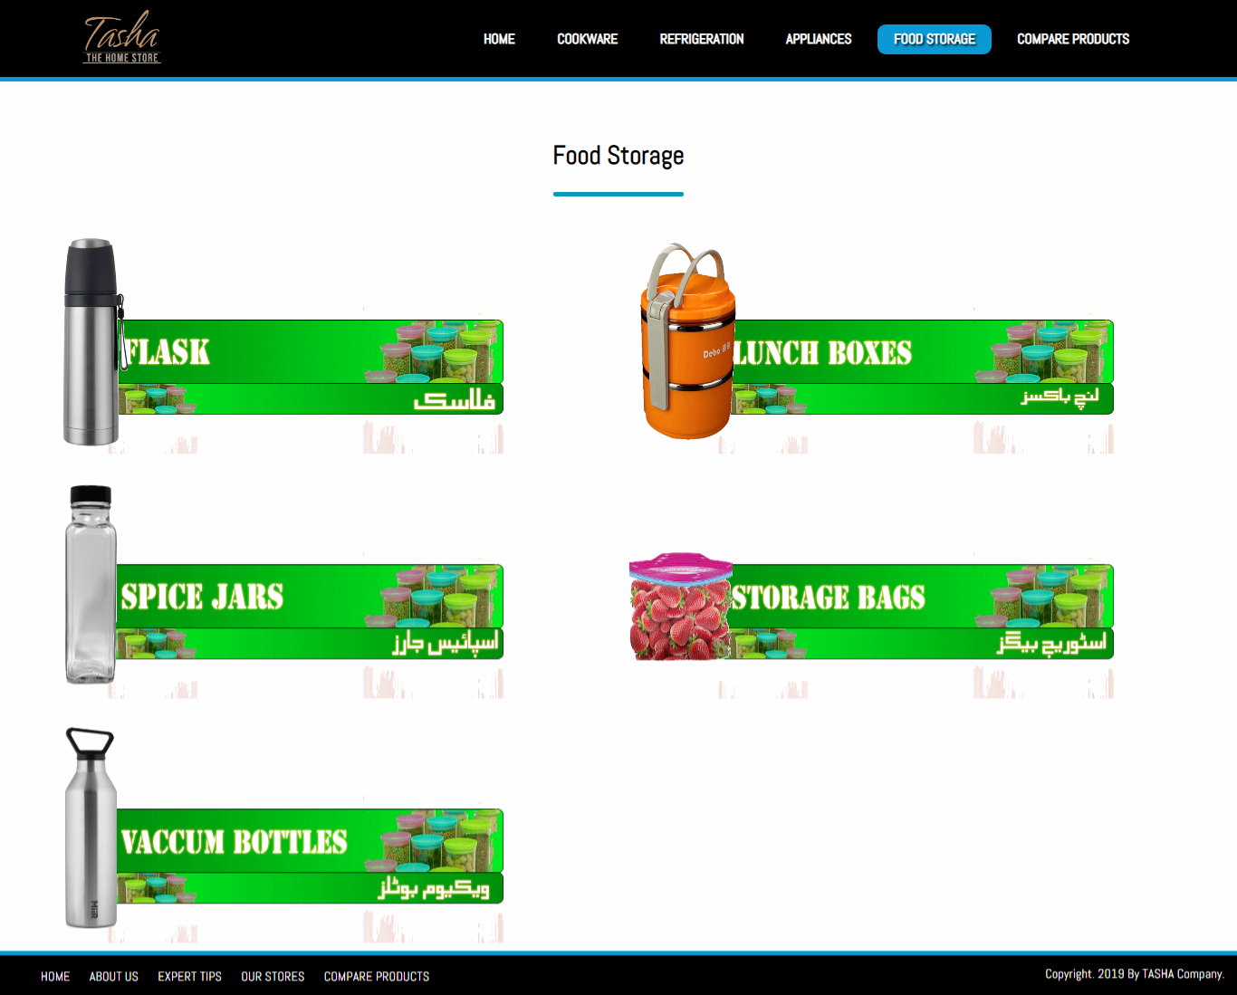

### *COMPARE PRODUCTS:*

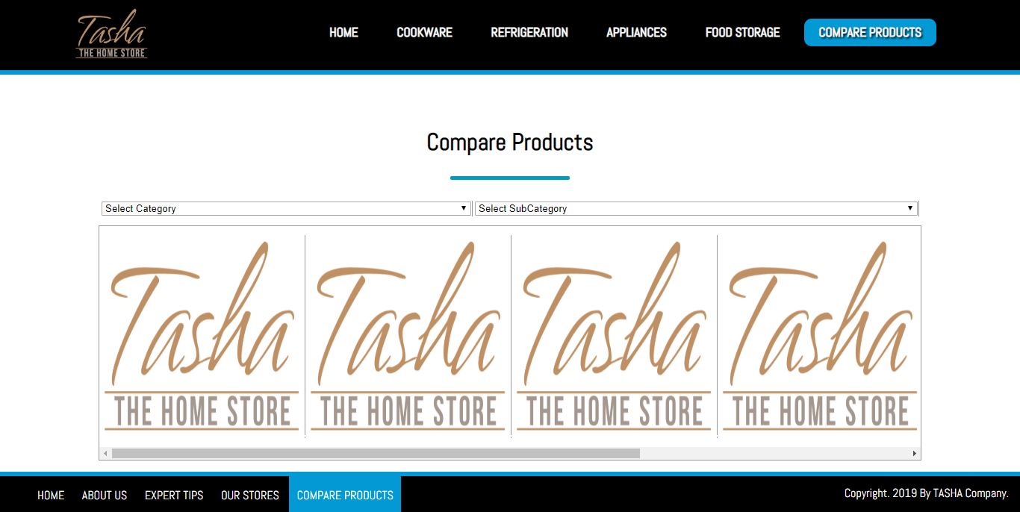

## SUB-DIVISIONS OF COOKWARE:

* *COOKING POTS: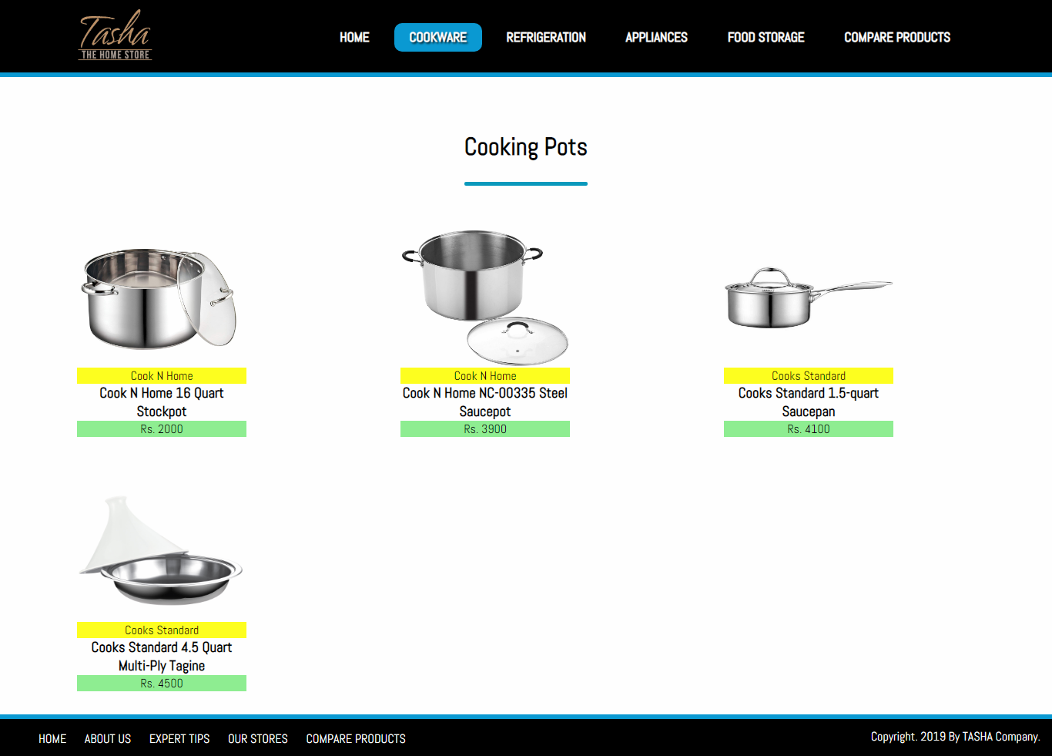*
* *COOKING PANS:*

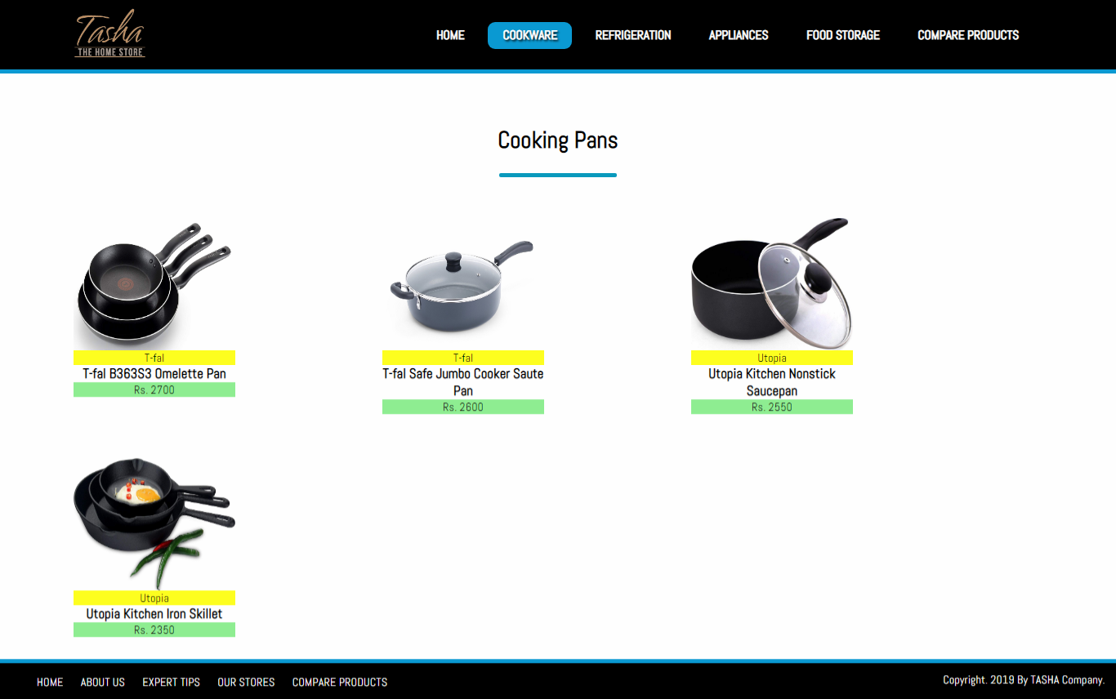

* *COOKWARE SETS:*

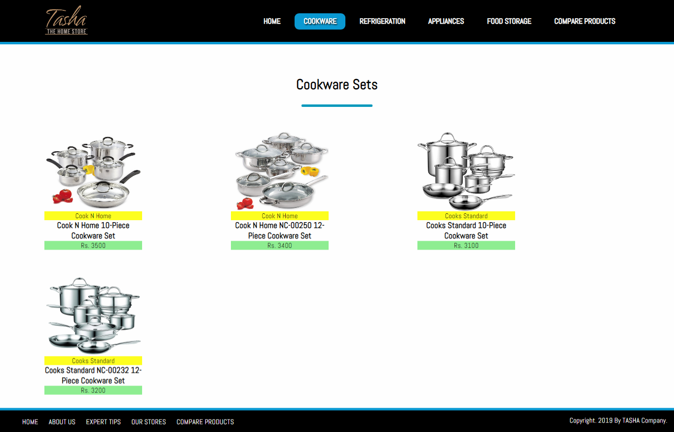

* *HANDI’S*

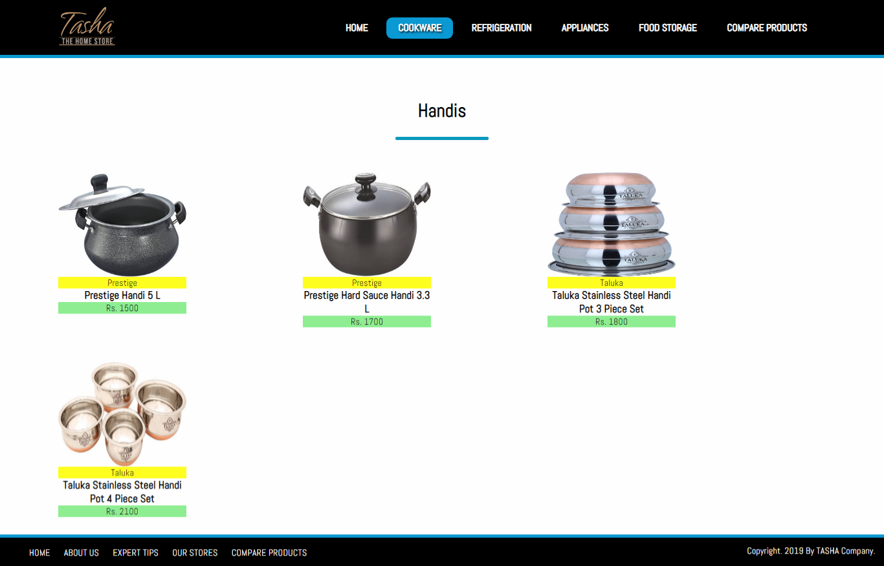

* *KADAI’S(KARAHI)*

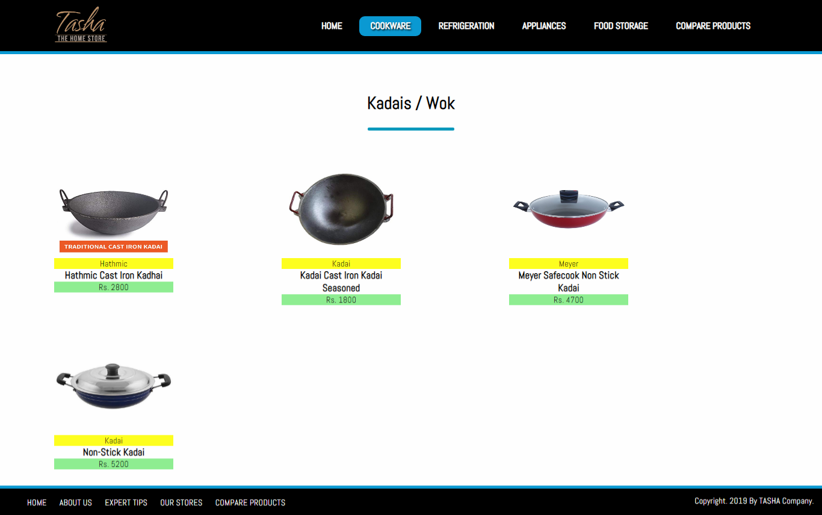

* *GRILL PANS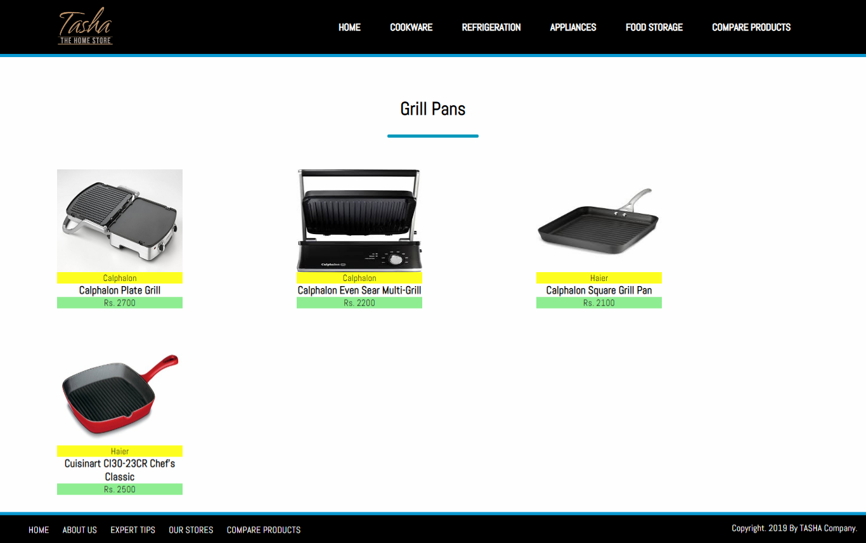*
* *TAWAS*

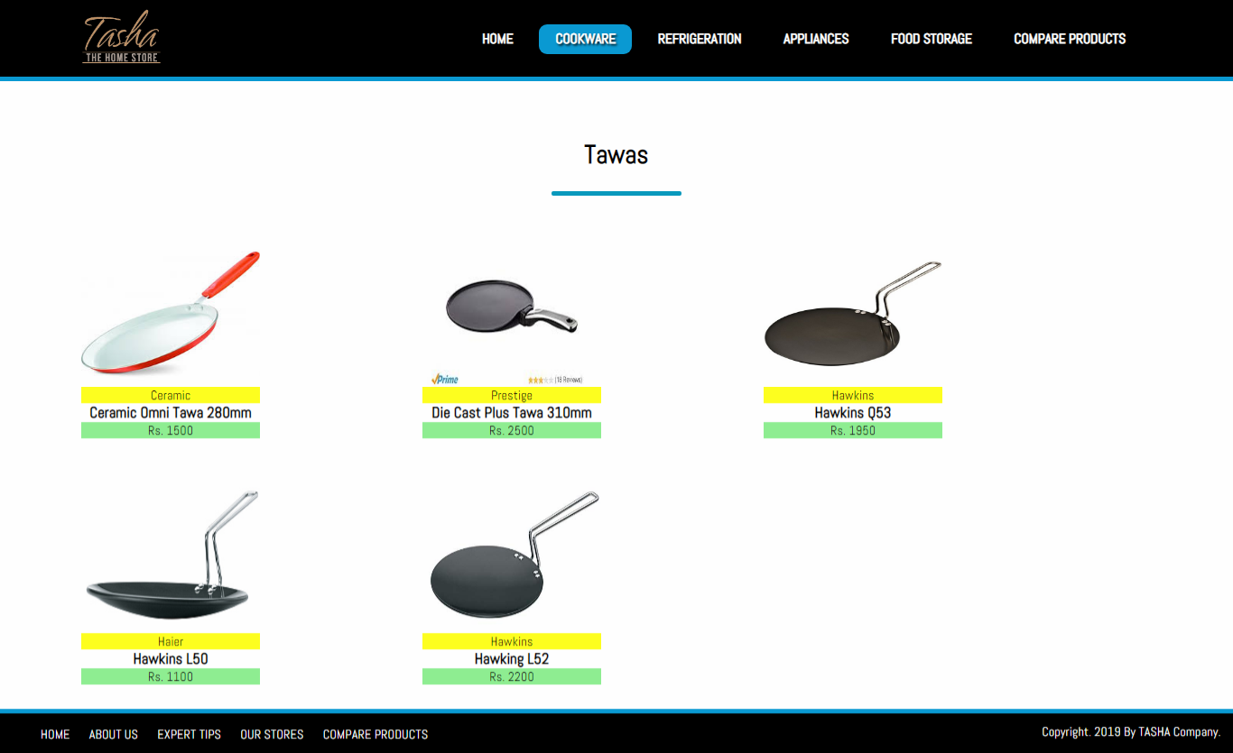

* *EGG POACHERS*

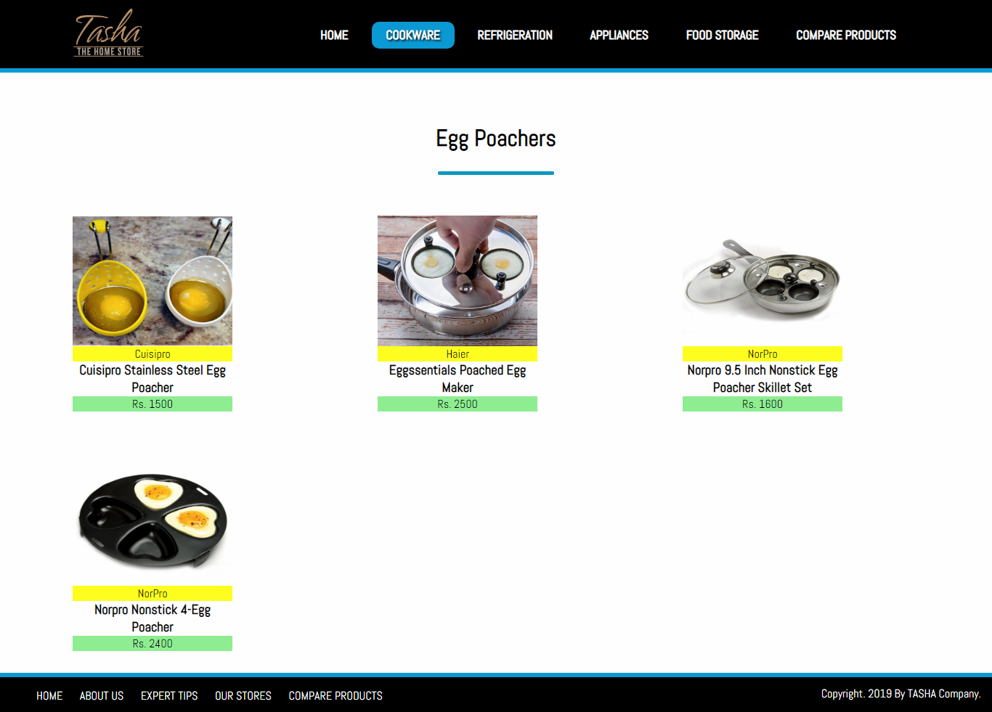

* *STEAMERS*

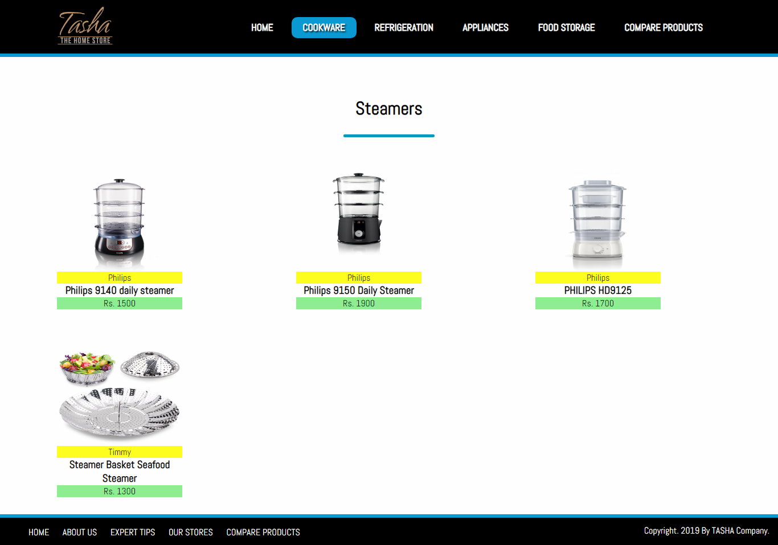

## SUB-DIVISIONS OF REFRIGERATION:

* *FREEZERS*

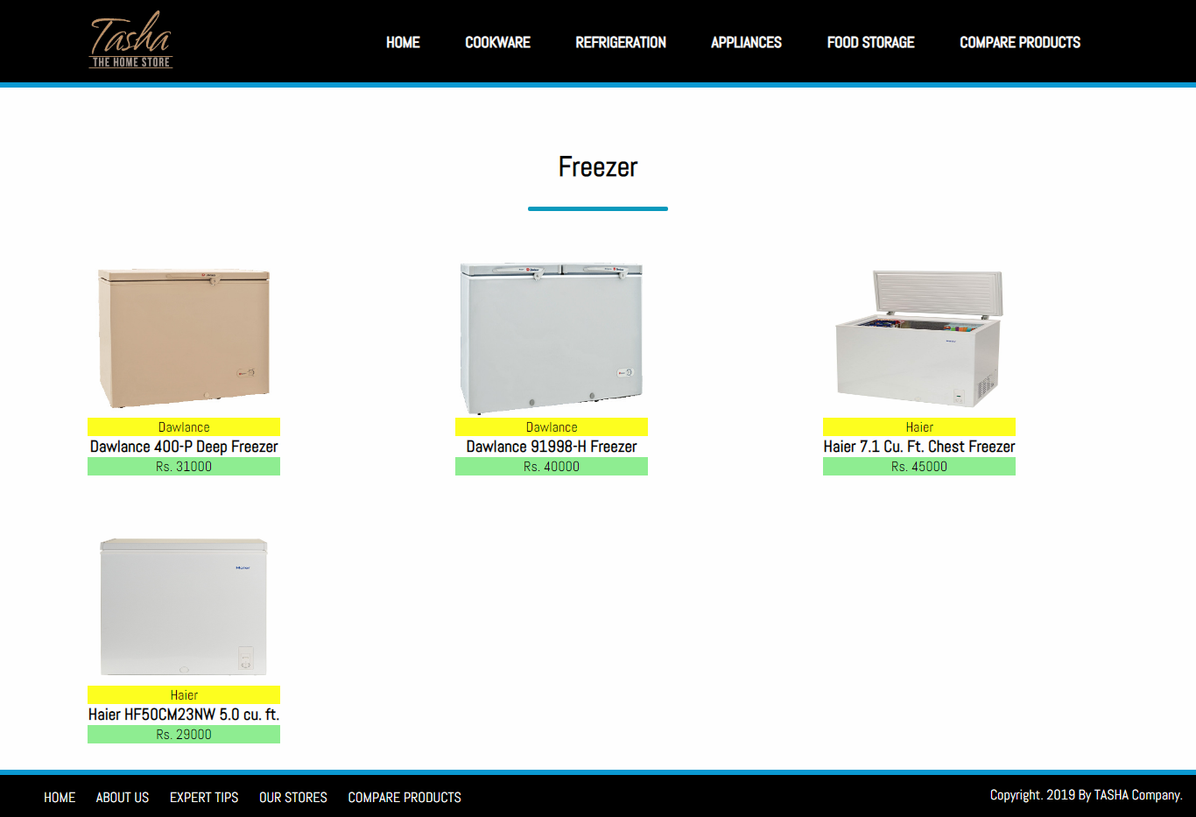

* *REFRIGERATOR*

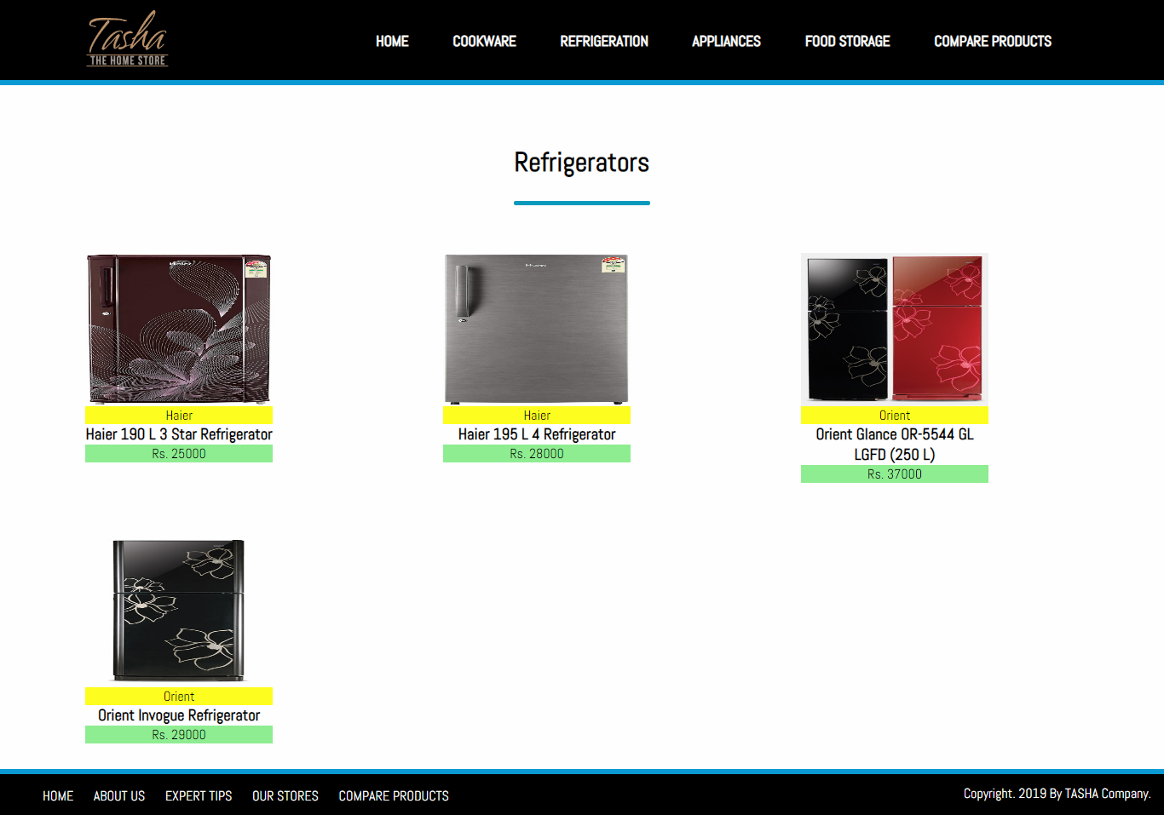

***SUB-DIVISIONS OF APPLIANCES:***

* *BLENDER*

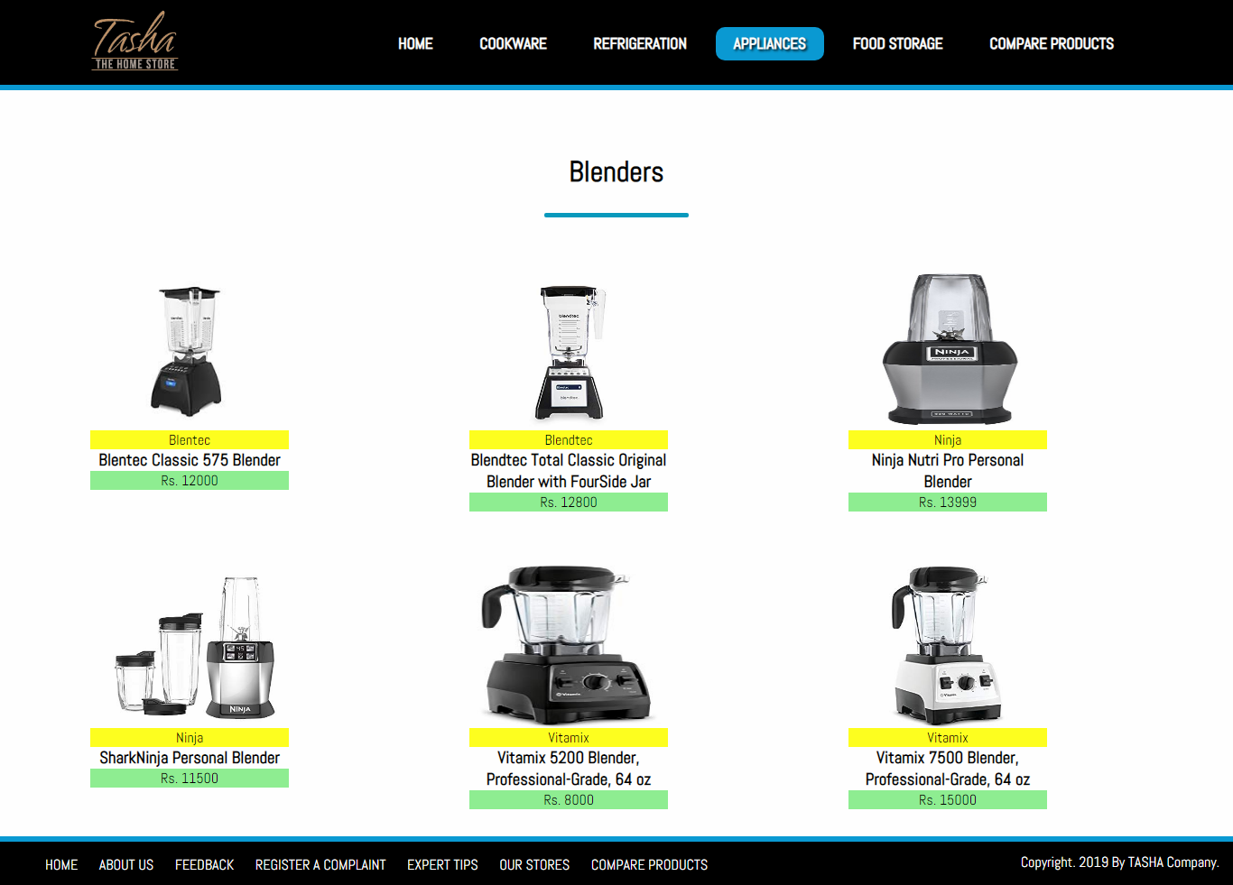

* *BREAD MAKER*

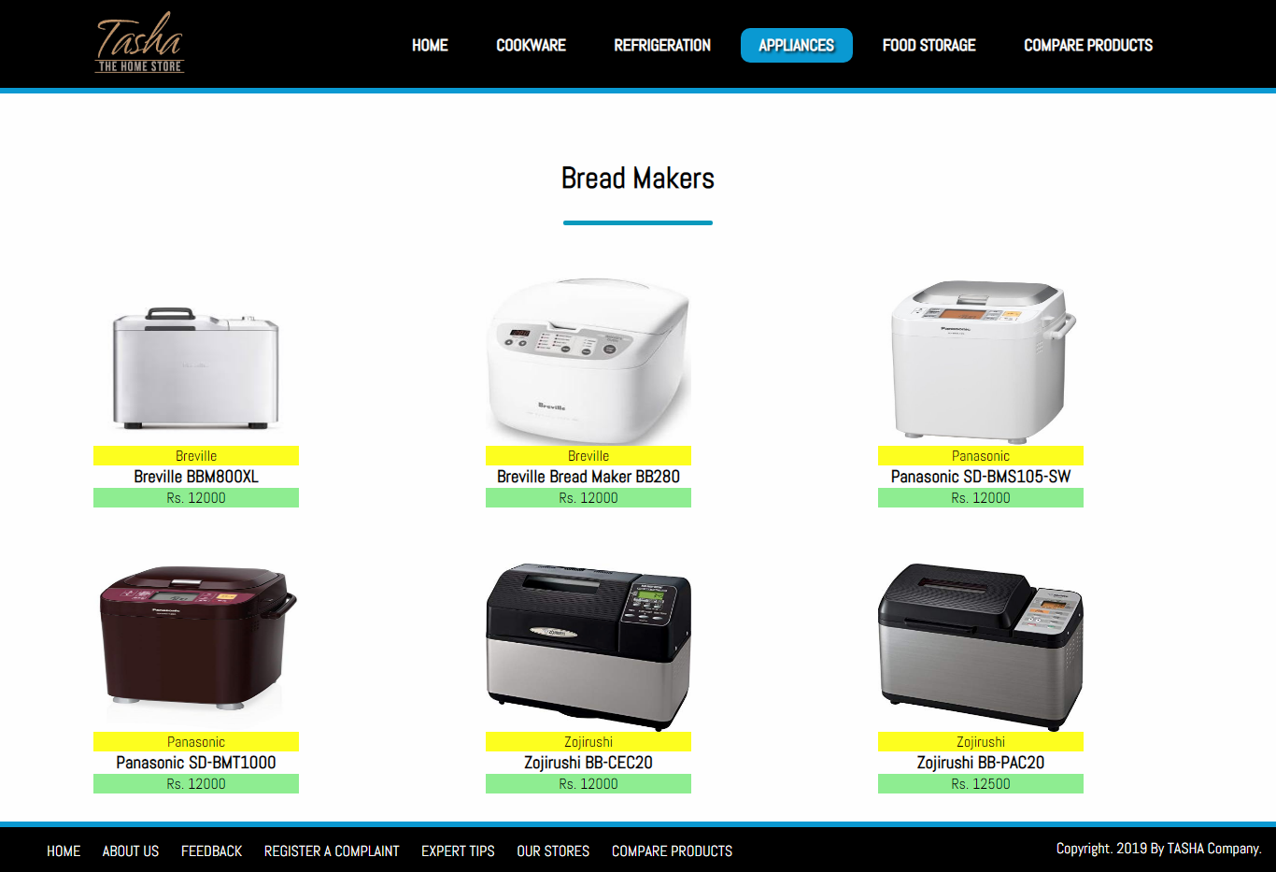

* *COFFEE MAKER*

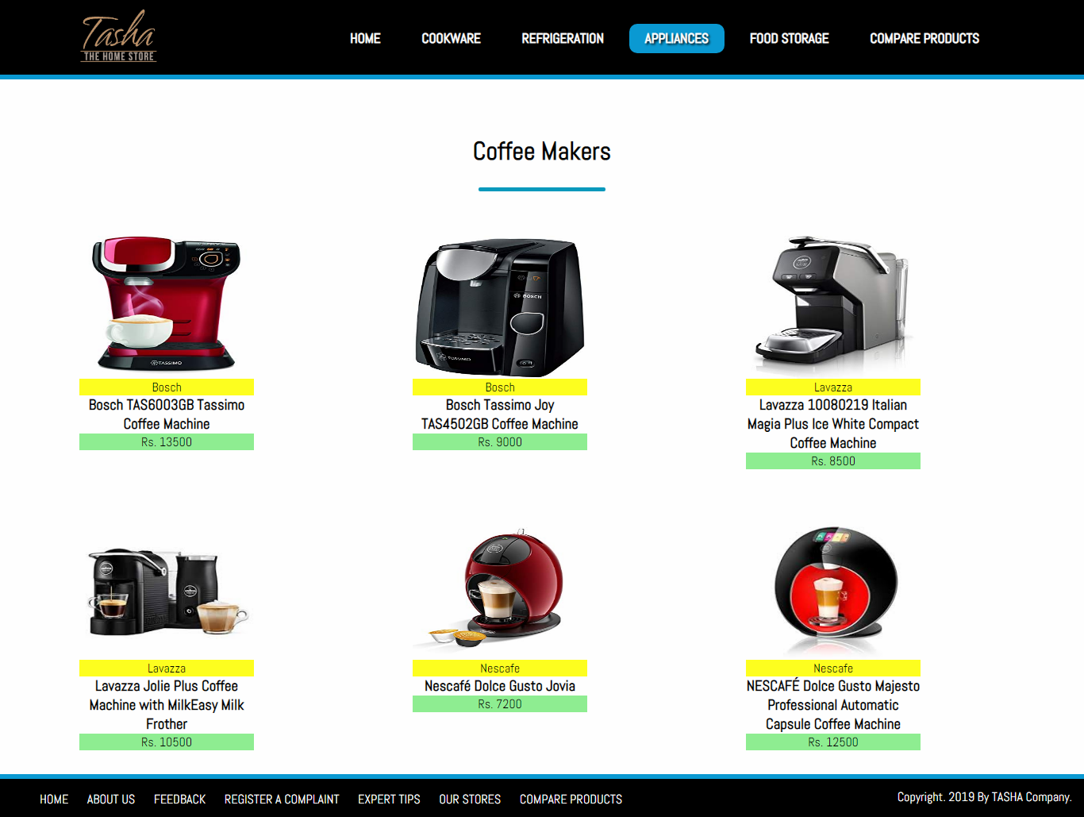

* *ICE CREAM AND SORBET MAKER*

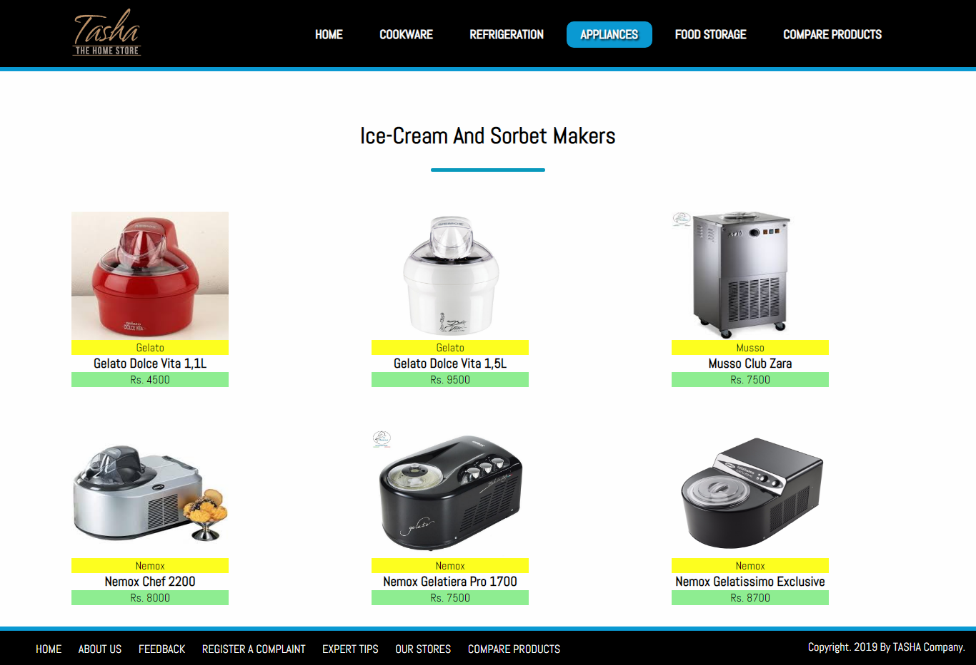

* *ELECTRIC KETTLE*

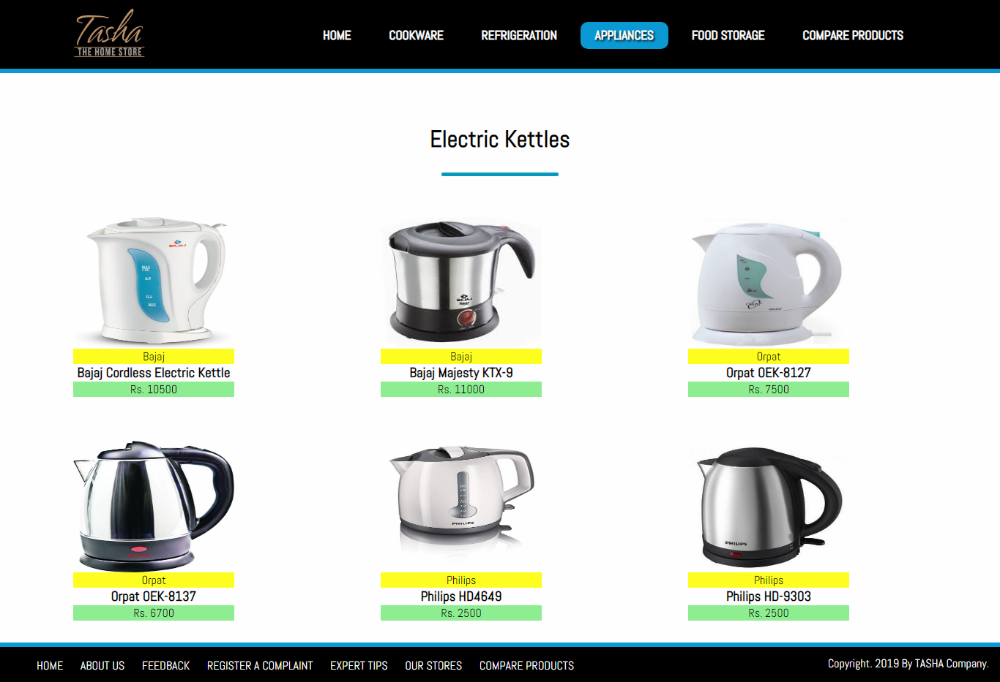

* *FOOD CHOPPER*

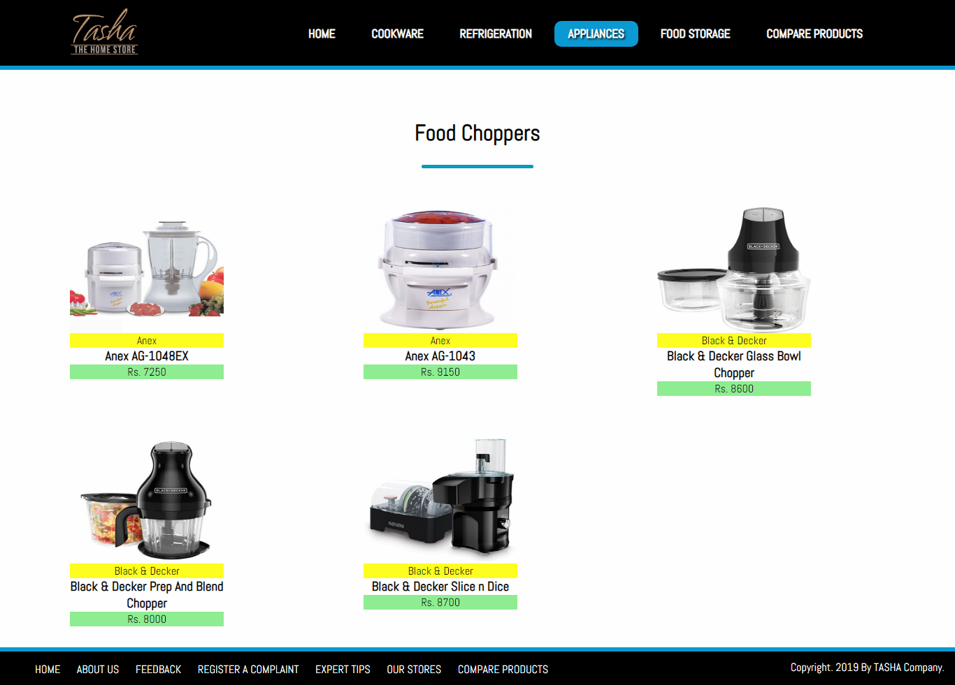

* *TOASTERS*

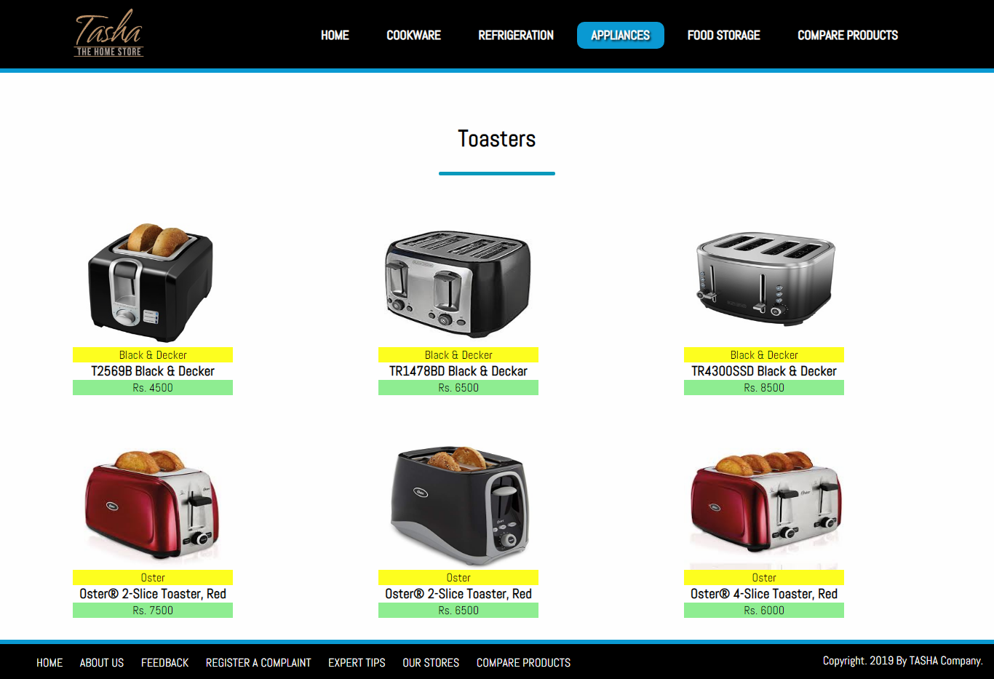

## SUB-DIVISIONS OF FOOD STORAGE:

* *FLASK*

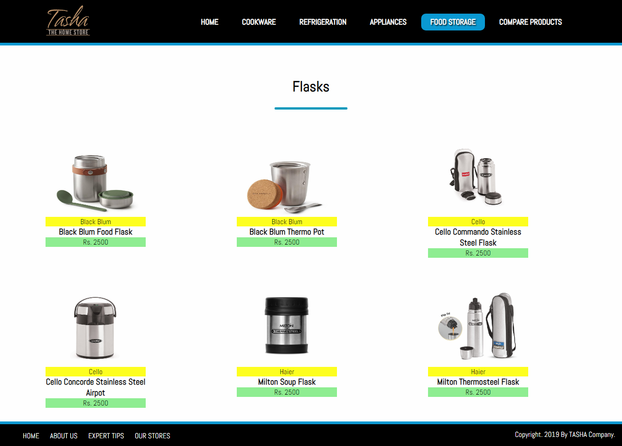

* *SPICE JARS*

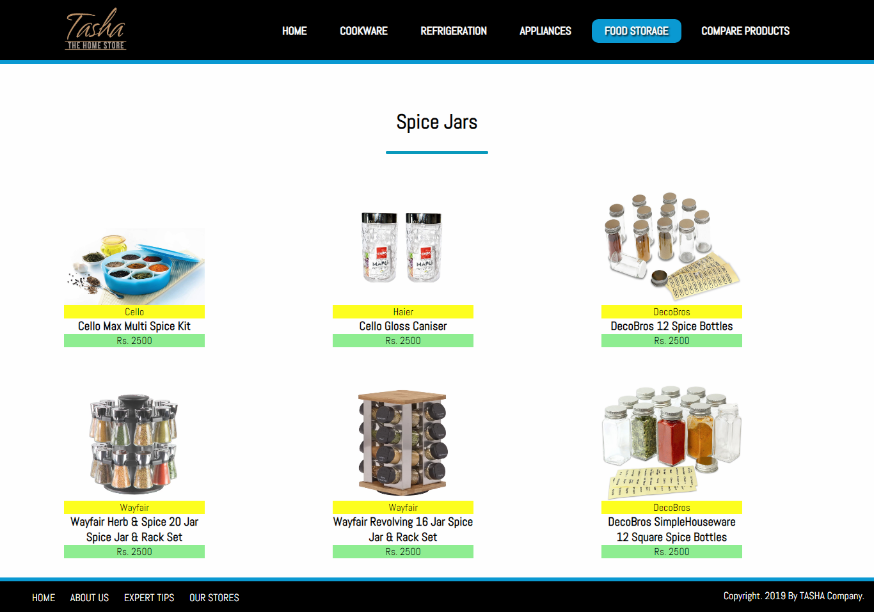

* *STORAGE BAGS*

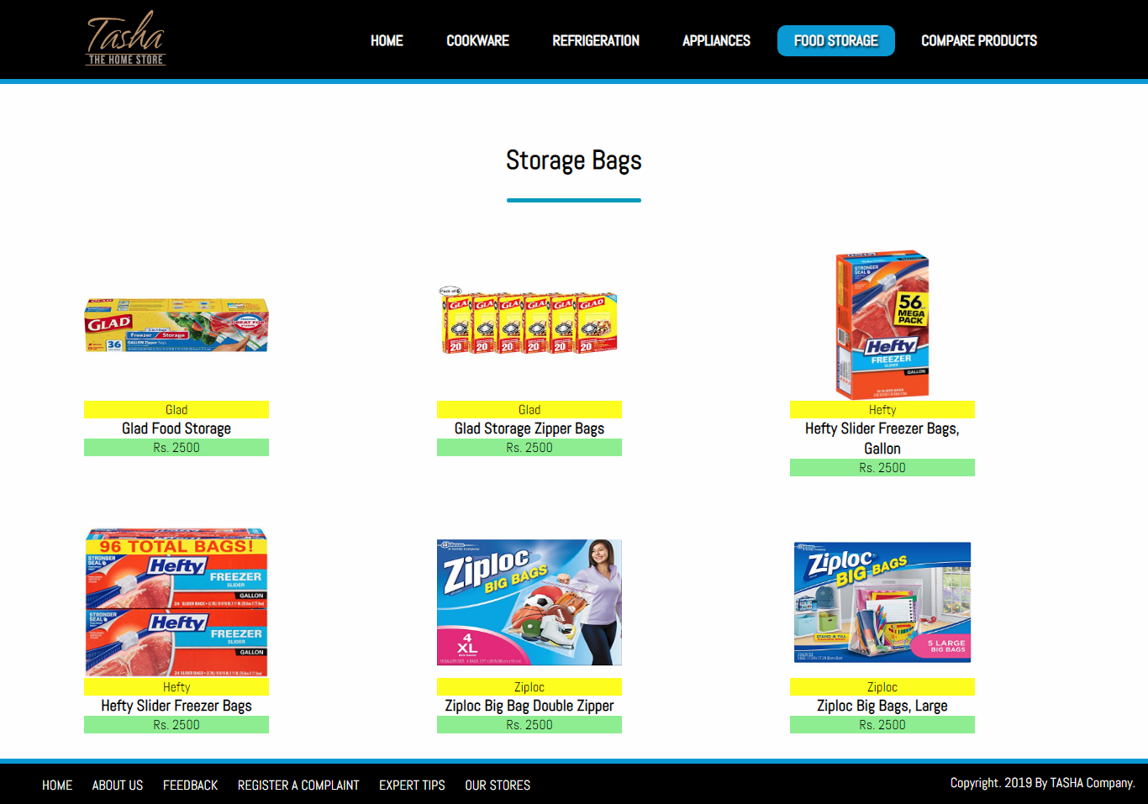

* *LUNCH BOXES*

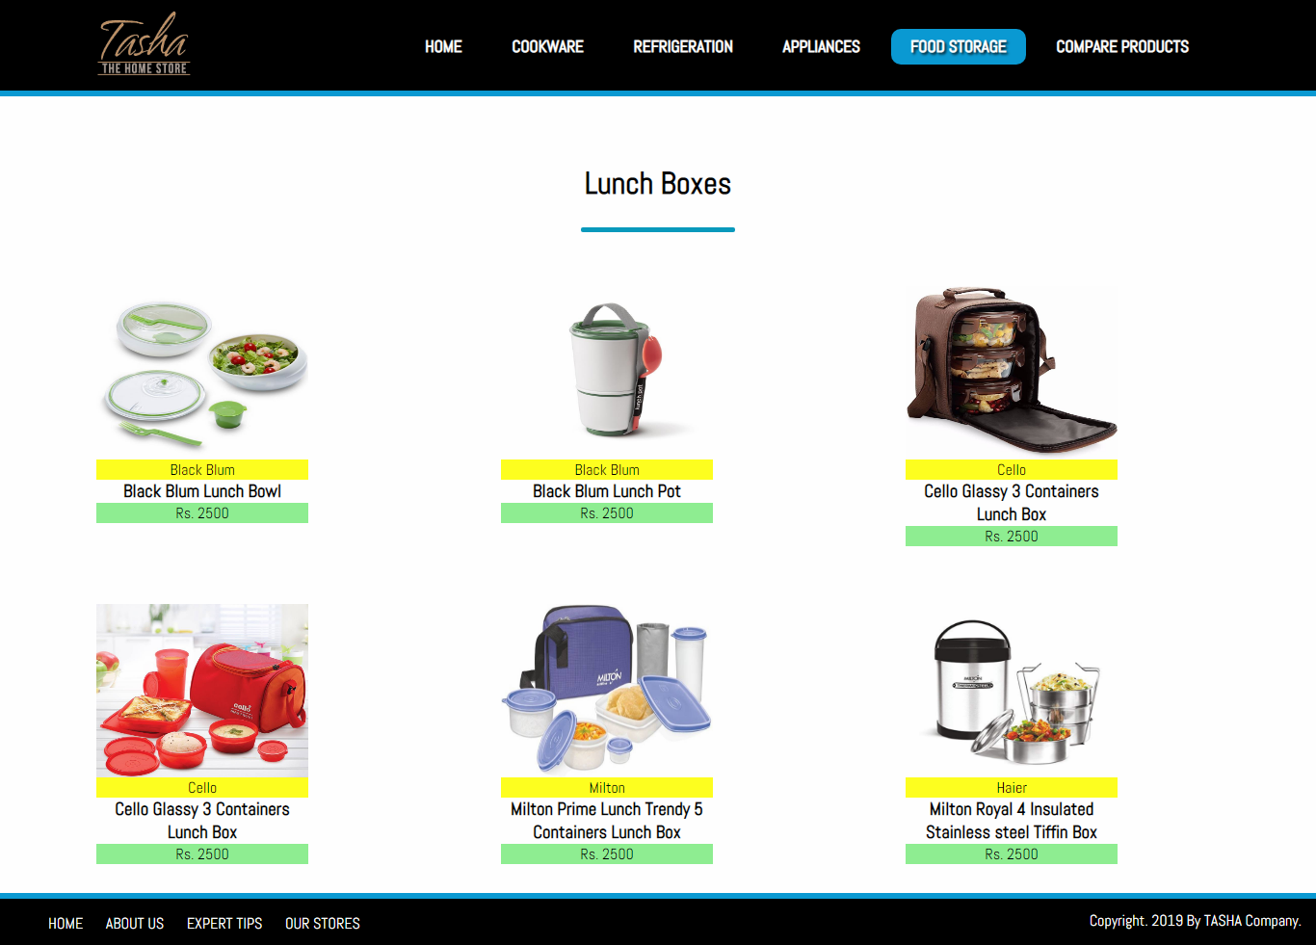

* *VACCUM BOTTLES*

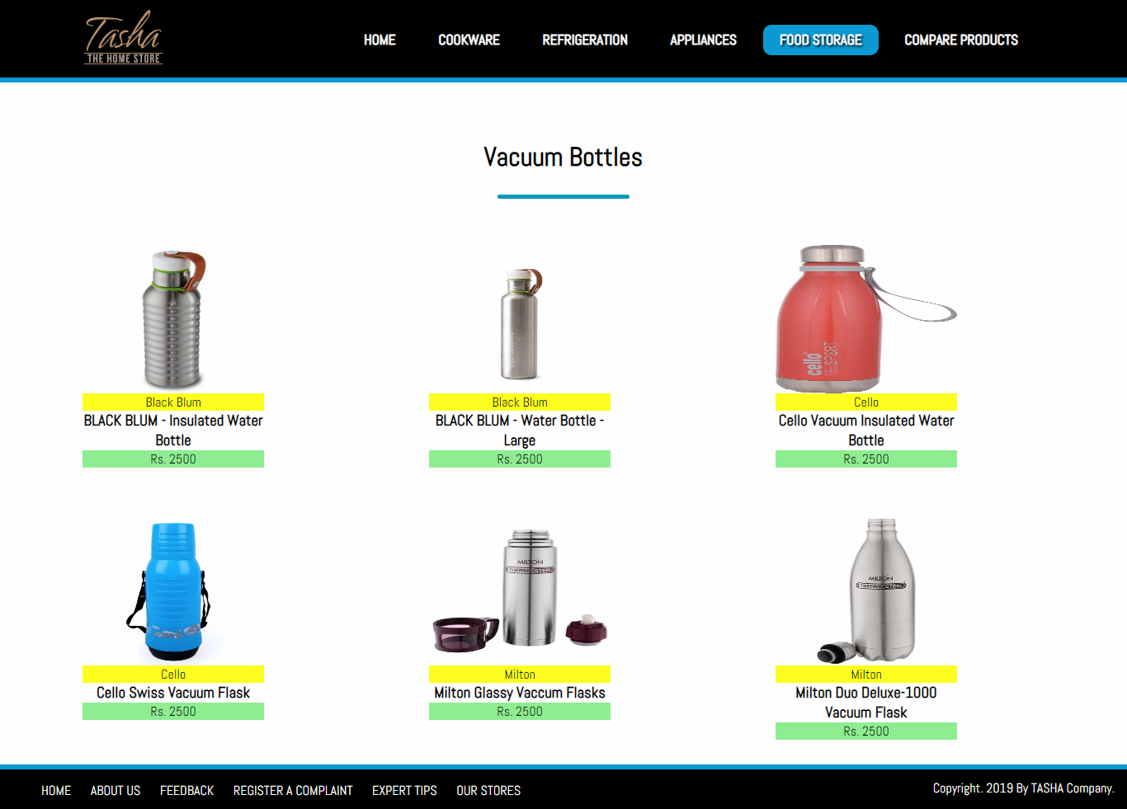

# *Developer’s Guide*

## COOKWARE

REFRIGERATION 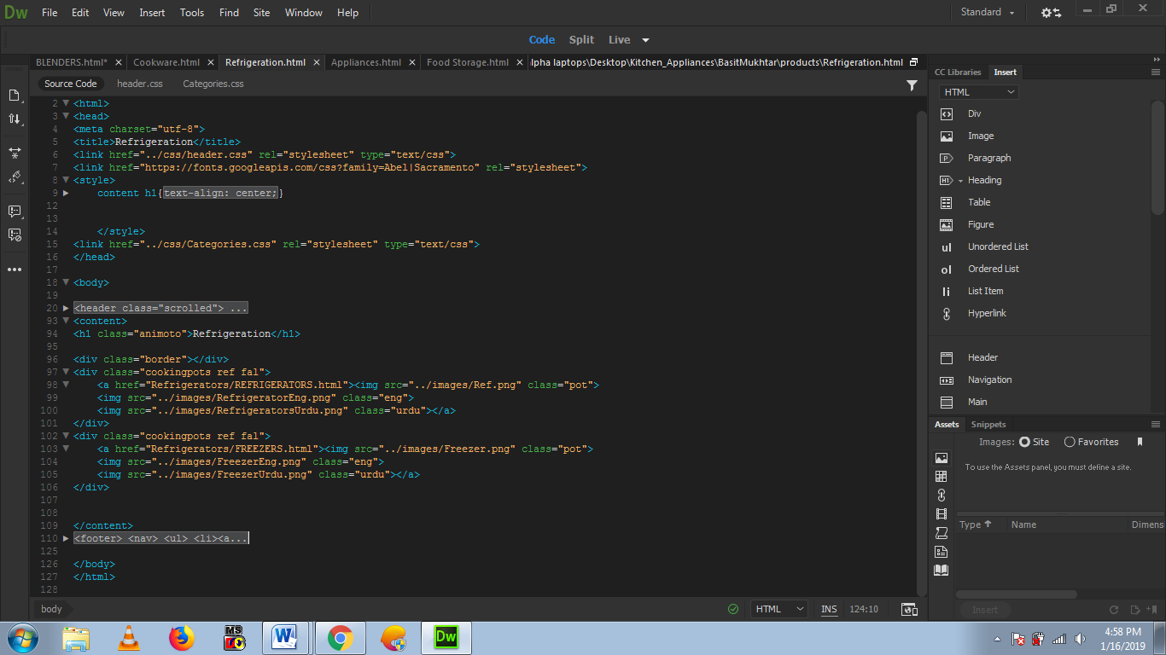

## APPLIANCES

## FOOD STORAGE

*OUR MAIN LOGICAL CODING CRITERIA:*

## COMPARE PRODUCT

**// Taking value from CATEGORY**

function kaam1(){

var x = document.getElementById("category").selectedIndex;

**// COOKWARE CATEGORY**

if(x == 1){

var z = document.getElementById("subcategory");

var op = document.createElement("option");

var op1 = document.createElement("option");

var op2 = document.createElement("option");

var op3 = document.createElement("option");

var op4 = document.createElement("option");

var op5 = document.createElement("option");

var op6 = document.createElement("option");

var op7 = document.createElement("option");

var op8 = document.createElement("option");

var op9 = document.createElement("option");

var op10 = document.createElement("option");

op.text="Select SubCategory";

op1.text="Cooking Pots";

op2.text="Cooking Pans";

op3.text="Frying Pans";

op4.text="Cookware Sets";

op5.text="Handis";

op6.text="Kadais";

op7.text="Grill Pans";

op8.text="Tawas";

op9.text="Egg Poachers";

op10.text="Steamers";

document.getElementById("subcategory").options.length = 0;

z.add(op);

z.add(op1);

z.add(op2);

z.add(op3);

z.add(op4);

z.add(op5);

z.add(op6);

z.add(op7);

z.add(op8);

z.add(op9);

z.add(op10);

}

**//Taking value from SUBCATEGORY**

function kaam2(){

var y = document.getElementById("subcategory").selectedIndex;

var w = document.getElementById("category").selectedIndex;

// Displaying COOKING POTS items

if(w == 1 && y == 1){

document.getElementById("img1").src="products/Cookware/Cooking Pots/images/Cook N Home 16 Quart Stockpot.jpg";

document.getElementById("img2").src="products/Cookware/Cooking Pots/images/Cook N Home NC-00335 Stainless Steel Saucepot.jpg";

document.getElementById("img3").src="products/Cookware/Cooking Pots/images/Cooks Standard 1.5-quart Multi-ply Clad Stainless Steel Saucepan.jpg";

document.getElementById("img4").src="products/Cookware/Cooking Pots/images/Cooks Standard 4.5 Quart Multi-Ply Clad Stainless Steel Tagine.jpg";

document.getElementById("img5").style.display="none";

document.getElementById("img6").style.display="none";

document.getElementById("txt1").innerHTML="<b>Cook N Home 16 Quart Stockpot</b> <br><br> Has a mirror-polished stainless steel body and an aluminum disc layered in bottom. Capsuled aluminum disc provides even heat distribution and prevents hot spots Tempered glass lid with steam vent to view food 500F oven safe, 350F for lid Handles are riveted for durability to carry; Large capacity for multiple uses Works on Induction, gas, electric, glass, ceramic, halogen, etc Dishwasher safe <br><br> <b>Rs/-2000 Only</b>";

*Task Sheet*

|  |  |  |  |  |
| --- | --- | --- | --- | --- |
| Project Ref. No. | | Project Title | Date of Preparation of Activity Plan | |
| S.No. | Task | **Kitchen Appliances** | Actual Days | Status |
| 1 | Analysis | 1 | OK |
| 2 | Design | 2 | OK |
| 3 | Development | 5 | OK |
| 4 | Testing | 1 | OK |
| 5 | Documentation | 1 | OK |